

**Department of Computer Science and Mathematics**

**CSC 491: Professional Experience**

Instructor:

Dr. Ramzi Haraty

Done by:

Nour Jalloul

Date: 1 August 2024

# Acknowledgement

Starting of June 2024, I did my internship at Areeba company as part of completing my BS degree in computer science. A professional working atmosphere filled with commitment and hard work among developers is a valuable pillar at this company. It was a great experience whereby I gained a lot of significant skills as well as knowledge within this company

I would like to thank **Dr. Ramzi Haraty** for his assistance and guidance through the course.

I would like to thank the **Mr. Wajeeh Zantoot and Mr. Ali Berro** for guiding me through this path and helping me establish a solid foundation in web development.

Contents

I. Acknowledgement 2

II. Abstract 4

III. Integrated Digital Systems: About the Company 5

IV. About the Internship 5

V. The Technical Skills 6

(i). Assignments 6

(a). Assignment 1 and 2 6

(b). Assignment 3 8

(c). Assignment 4 9

(d). Assignment 5 10

(e). Assignment 6 12

(ii). Final Project 14

VI. The Soft Skills 22

(i). Communication Skills 22

(ii). Self-Learning 22

VII. University Courses Used in the Internship 22

CSC 375 Databases Management Systems: 22

CSC 490 Software Engineering: 23

VIII. Future Expectations 23

IX. Conclusion 23

1. Letter of Intent……………………………………………………………………..…….25
2. Training Certificate…………………………………………………………………...……27
3. Employer's Signiture…………………………………………………………………….....28
4. References ………………………………………………………………………………..29

# Abstract

As part of the computer science program at LAU, students are prepared to encounter real work load and are prepared to get engaged in the ever evolving world of technology. These students are set to become employees where they apply what they have learnt during their university years. For this purpose, the university encourages its students to take part in internship programs that act as an opening door for their future employment plans. The internship’s intents are to learn new skills in the field of work, in addition to applying what has been learnt in actual life, along with gaining the expertise needed to get prepared for the work life. At Areeba, the opportunity of both learning new skills and the ability to implement what was learnt at university was available. Both technical and soft skills in terms of dealing with team were soundly used. This report highlights what has been done through my internship in terms of different assignments given and the final project, using new skills and the skills acquired at the university.

# Integrated Digital Systems: About the Company

IDS, which stands for Integrated Digital Systems, is a leading software development company that provides Enterprise Resource Planning (ERP) products, Archiving Solutions, Document Management, Wealth Management, Online Trading, e-commerce, and e-government solution. The company designs and develops mobile applications and websites that assists business in acknowledging the power of data, social collaboration, cloud computing, and next generation tools for the enterprises (IDS,2018). The company is part of the Microsoft Partner Network and has been a Microsoft Certified Partner since 2001(IDS,2018). IDS builds programs that tackle business issues and strengths the use of technology to empower organizations to work all the more proficiently with more visibility and control over the supply chain.

# About the Internship

The internship was a three months’ online internship about web programming using visual studio, where different assignments were posted to us via a forum online, explaining what we should do and providing different useful resources to learn form. The forum was a meeting point between the interns, where we switched knowledge between each other, in addition to being a bridge between the interns and the employees at the company where we could ask whatever wasn’t clear or what we couldn’t do. We also had to pass by once every week to present what we have done and discuss different ways of improving it. After being assigned different assignments during the first 2 months, a project was given in which we applied on all what has been learned.

# The Technical Skills

### (i)Assignments:

**In our assignments, we were taught about back end developing of websites and didn’t really focus on the design part.**

#### (a) Assignments 1 and 2:

In our first lesson we were taught how to use both HTML and CSS when building up a website. Since I had no experience in web programming, I went on to learn it using w3schools and YouTube videos. I figured out how html language builds up the different content of the webpage and how it divides it into different parts and how a website can be chopped into different sections and each section can be managed. However, I figured out that the design part is missing and so we must use css in order to refine the shape of the website and add a texture to the website. So, for our first assignment, we had to design a CV webpage which must include a header, a footer, a picture, a list, and of course formatted text. Through what I have learned, I managed to build a responsive front end, which contains 4 different sections, an introduction, my skills, my interests and a contact me form, each with different types of designs using css. Also, we were asked to host our website on google drive, and so I did by creating a public folder on Google Drive and uploading the html and css files and then previewing them and getting the URL address.

As for the second lesson, we were taught how to use jquery and javascript which allow us to add action to our website and traverse it properly. In order to practice what we learned, we were asked to add a tab system to switch between sections, an animated slider and a contact me form. What I have done is using these languages to create a navigation bar on top of the page which when pressed on one takes you to the proper section and that’s by using jquery.

|  |  |  |
| --- | --- | --- |
| <script>  $( **function**() {  $( "#tabs" ).tabs();  } );  </script> | | |
|  | Also, for creating the animation slider, I also used jquery in order to slide the images, where the |  |

division of the slider and that’s by loading jQuery simple slideshow library. As for the contact me form, we were required to validate the input by using javaScript functions which checks if fields are empty and if there were any other errors. At the end of lesson 2 we were asked to recap about what we have learned.



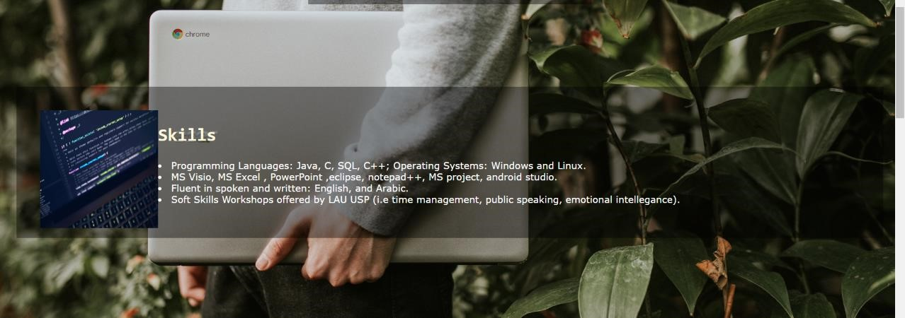

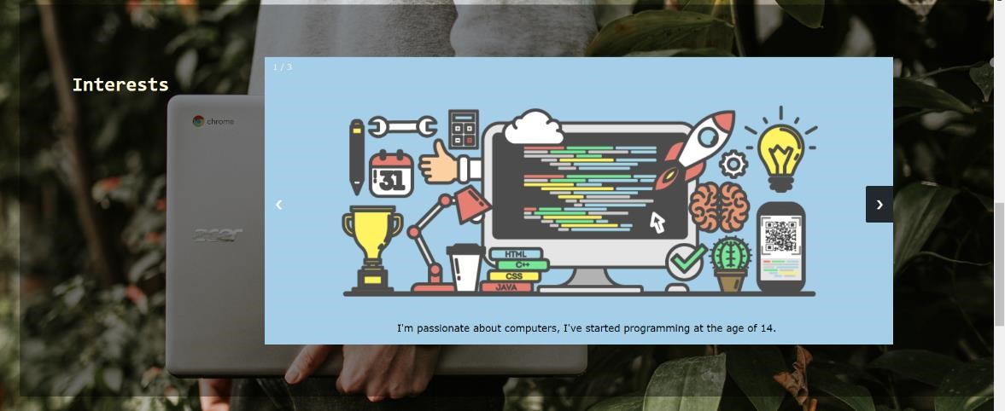





##### (b) Assignment 3:

In assignment 3, we had to learn about SQL language, but since I’ve already taken the database course, there was no need to learn it again. We were also asked to design our own database using Microsoft SQL Server. We must build the tables, that contain both foreign and primary keys and generate ER diagram, then fill the database with data. For creating the tables, CREATE function was used, and for setting the primary key PRIMARY KEY attribute was used, as for the foreign key FOREIGN KEY attribute, and INSERT function for inserting data.

Example on CREATE:

CREATE TABLE [dbo].[Address](

[add_id] [int] NOT NULL,

[loc_id] [int] NOT NULL,

[cand_id] [int] NOT NULL,

CONSTRAINT [PK_Address] PRIMARY KEY CLUSTERED

CONSTRAINT [FK_Address_Address] FOREIGN KEY([add_id])

REFERENCES [dbo].[location] ([loc_id])

CONSTRAINT [FK_Address_Candidate] FOREIGN KEY([cand_id])

REFERENCES [dbo].[Candidate] ([can_id])

Example on INSERT:

INSERT [dbo].[References] ([cand_id], [ref_id], [ref_name],

[ref_position], [ref_email], [ref_phone]) VALUES (1, 1, N'Youmna Nasser',

N'Student', N'youmna.nasser@lau.edu', N'76160365')

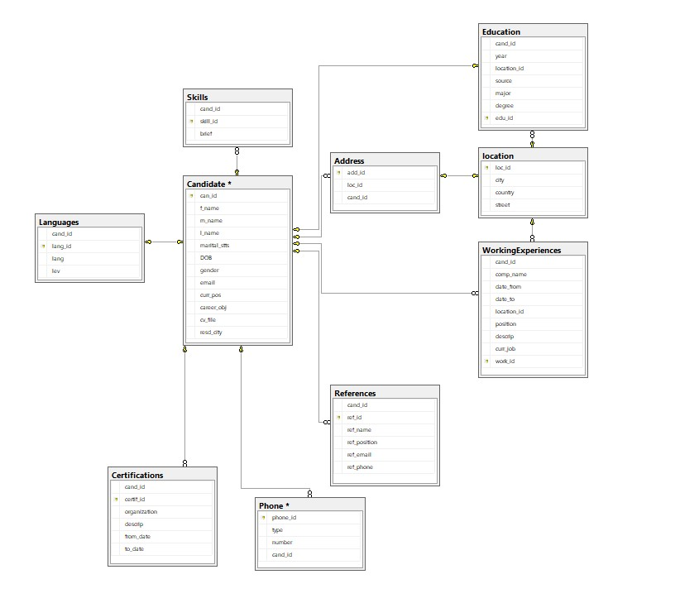

###### (c) Assignment 4:

In our 4th lesson, we had to learn about entity framework, We had to transform our database into objects to make our coding easier and that was done using the Entity Framework under Microsoft Visual Studio. Entity Framework allows the developers to work with their data stored in the database using objects of domain specific classes without concentrating on the underlying database’s tables that keeps the actual data.

We were asked to create a simple webpage (.aspx) using C# or VB, open a

connection with the database from the aspx page, and show the list of candidates added to the database with displaying the results in this webpage.

First, to create a simple webpage (.aspx) this could be done by creating a new project, selecting Visual C# >> Web >> ASP.NET Web Application, and that can also be done by adjusting the connection string in the in Web.config file. As for establishing a connection from the database, this could be manually by adding a new item to the webpage that is the SQL Server Database. As for displaying the candidate, we tried doing it in 2 ways, either with a repeater class, that creates a new entites(), which resembles the database connection that gets the tables in the database, and applying a query that gets the information from the table, all are gotten as a form of tolist(), then binding it to a repeater. Another way would be explicitly creating a grid view.

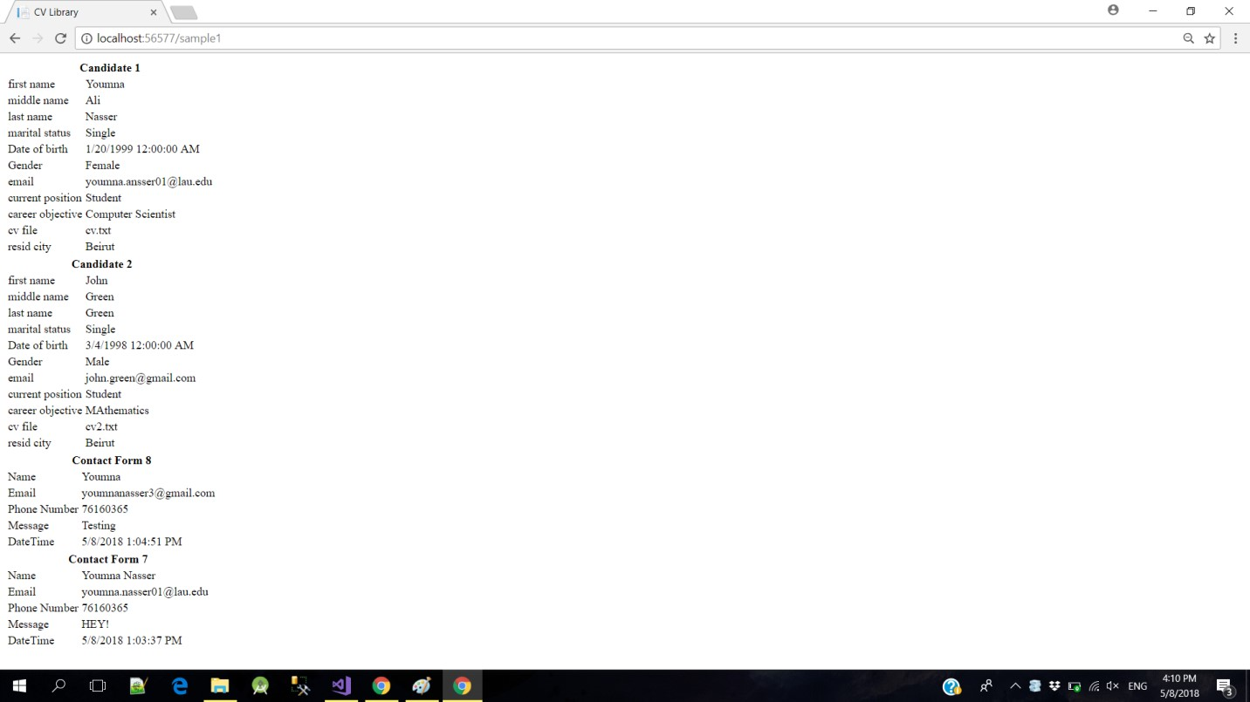

(d) Assignment 5:

In this assignment, we were asked to learn about ASP Membership provider, that adds security and permissions to the website. ASP membership provider enables the developers to have a unique account, with a username and a password. This feature requires having a connection with SQLServer to store user information. So, we were requested to add user/admin role to the users registered, add a page to manage the registered users, and give them the desired permissions (Admin role or User role), create a page to manage the candidates in the database that shows a grid view that also previews the options of creating or editing or deleting candidates, in addition to add permissions to "Manage candidate" page & "Manage Users", where only admins can see this page.

In order to set up the asp membership provider, we learned to enter “aspnet_regsql” in the command line prompt and manage things up from here, this will manage in creating additional tables to the database that are necessary for authentication. As for the login/register webpage, it will be explicitly designed by the visual studio, and it could be done easily by using database entities’ build-in function Add, and querying to check if username and password exit and match in login procedures.

What I have done to assign roles and manage user’s info and put permissions, is that I created a controller that contains different methods for different purposes. A method was written which directs the user into another page to assign roles to the users which is authorized to only admins through [Authorize(Roles=”admin”)]. Whenever the admin clicks on the button corresponding to this page, a new View is created which is a .cshtml that corresponds using the following code the name with a role.

@using (Html.BeginForm("RoleAddToUser", "Roles"))

{

@Html.AntiForgeryToken()

@Html.ValidationSummary(true)

<p>

Username : @Html.TextBox("UserName")

Role Name: @Html.DropDownList("RoleName", (IEnumerable<SelectListItem>)ViewBag.Roles,

"Select ...")

</p>

<input type="submit" value="Save" />

}

As mentioned previously, in order to give permissions to the methods I used

[Authorize(Roles=”admin”)], as for the grid view, it could be dragged and dropped, and then linked to the entities by choosing data source. Also, adding/deleting/editing users could also be added by auto generating these options.

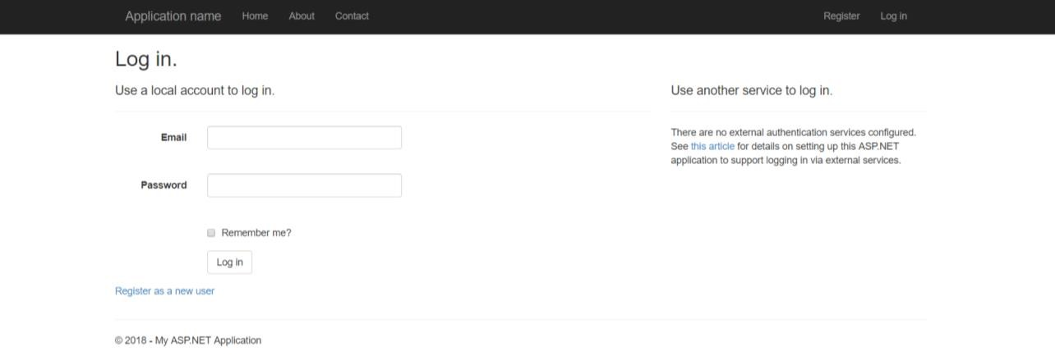

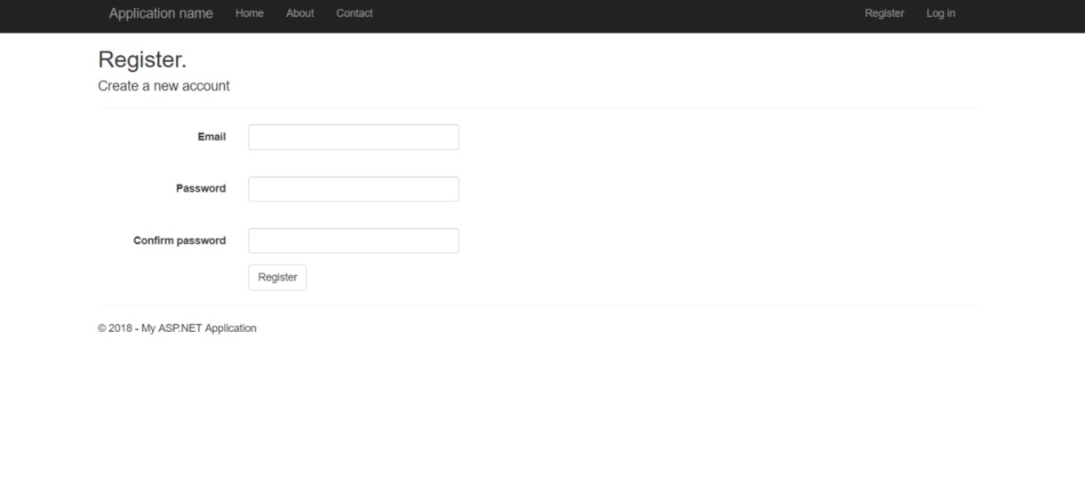

#### (e) Assignment 6:

In our last assignment, we learnt about Web Services. Web Services are used to provide communication between different web applications. We had to use web services in this assignment by using ajax. We have learnt that ajax stands for Asynchronous [JavaScript](https://skillcrush.com/2018/04/16/javascript-jobs/) and XML. Using web services helps in reducing the post backs in the webpage in addition to reducing the time waiting to get data and to update it. For testing this service, we were requested to create a web service to get the list of Candidates in addition to the Candidate details by sending the Candidate Id to the service. We were also asked to use the created web-services in the backend pages already created before and load Candidate data using the web-service and manage their information using the related methods. This was done by adding a web service page that includes the methods to get the candidates information. In order to be able to use the web service in the backend pages already created, javascript functions had to be implemented, that get the candidate by id, receives result from the webpage successfully and another one that receives errors from web service.

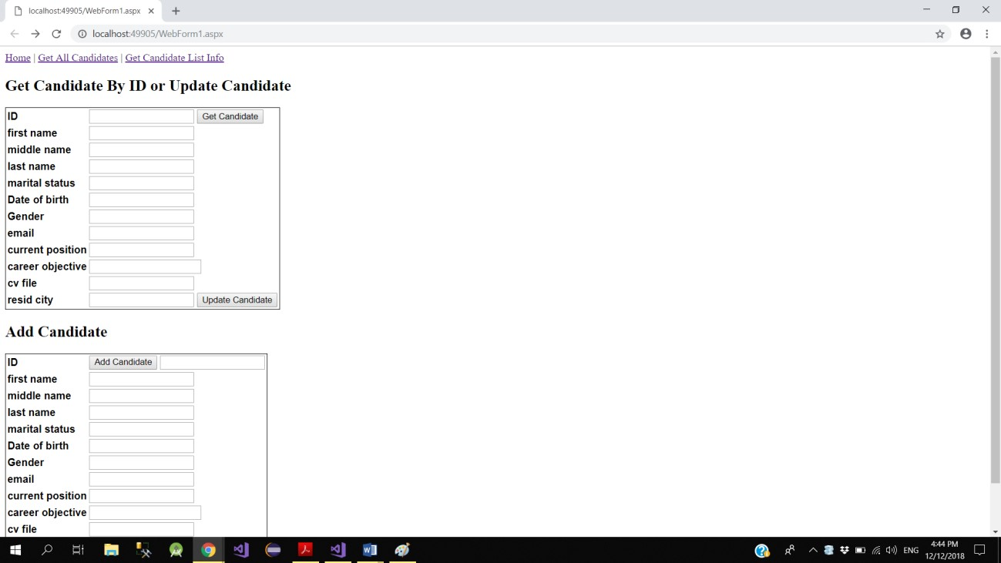

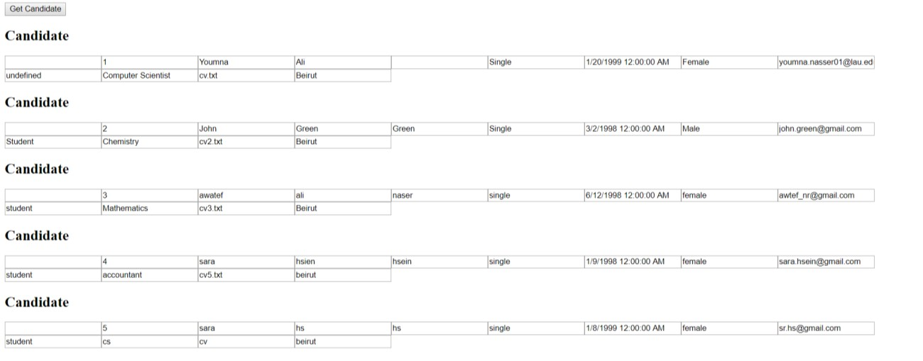

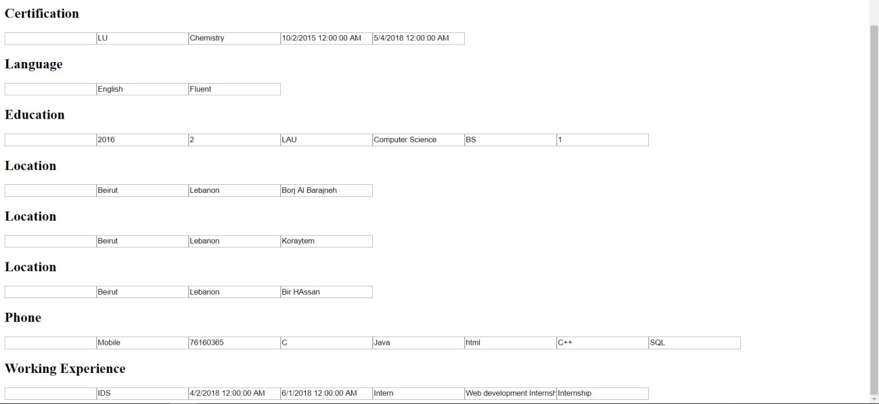

Web service:

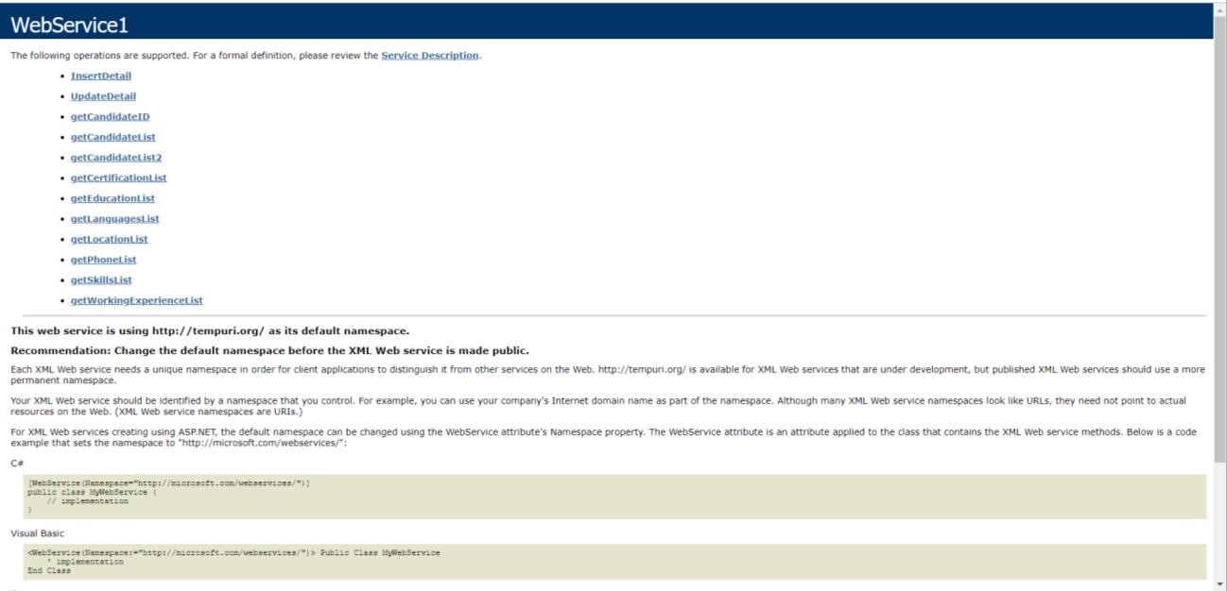

### (ii) Final Project:

In the final project, I was asked to implement an attendance management program with specific features in which everything that was taught gets covered in this final project.

The design phase starts by planning an overall picture of how the system will be, what will it include, the webpages and how they will be related. It first started by creating the database using sql server, that included information about every registered user and the activities done during his login session. The database consists of

1-users table, that mainly includes his email, password, name, role, job and department, stores the information of the employee/manager

2-roles table: roleid, rolename, that assigns roles

3-department: department name and id

4-job: jobname and id

5-employee working: Name, date, time in, time out, comment, id, email, duration, address, which stores real time information of checks in and out done by the user

6-address: addres name, location X, location Y

7-working day: email, total working hours, starting time of the day, ending time of the day, which stores the daily information of every user

8-holiday: starting time, ending time, total working hours, which puts the time limits for throughout the system

9-holidays: date of the holiday, which sets the holidays in which the employee isn’t allowed to work in

The work then starts using Visual Studio 2017, as I start by working on the asp membership provider, which ensures a registration and login pages, the same implementation way as mentioned above. Then, I start working on the record real time attendance page, where I worked on putting a clock in addition to a timer by simply adding it from the toolbox in visual studio in addition to performing other minor changes. This page displays the check in and check out buttons, in addition to a text box with the location suggestion, as it has been implemented with using Ajax autocompletextender control and web service These information are all saved inside the database by using the entities built-in function ADD. Then, I created the grid view that displays the registered users and their real time attendance records. This page was implemented as I did in the assignments, but the difference here is that the delete/add/update options are implemented manually using specific methods which apply the changes using database entities., for example when deleting:

int employeeid = (int)myGridview.DataKeys[e.RowIndex]["Employeeid"]; using (MyDatabaseEntities dc = new MyDatabaseEntities())

{

var v = dc.Employees.Where(a =>

a.Employeeid.Equals(employeeid)).FirstOrDefault();

if (v != null)

{

dc.Employees.Remove(v); dc.SaveChanges();

PopulateContacts();

}

}

In addition, a page was also created in order to manage the time limits that are set by the company and the days that are set as holidays. This was done by adding a calendar control from the tool bar in addition implementing the methods needed in order to highlight the holidays. Moreover, an address management page was also created that lets the managers set the addresses in which the employees can go to. In addition, a vertical side bar was implemented with a normal html page.

Registering:

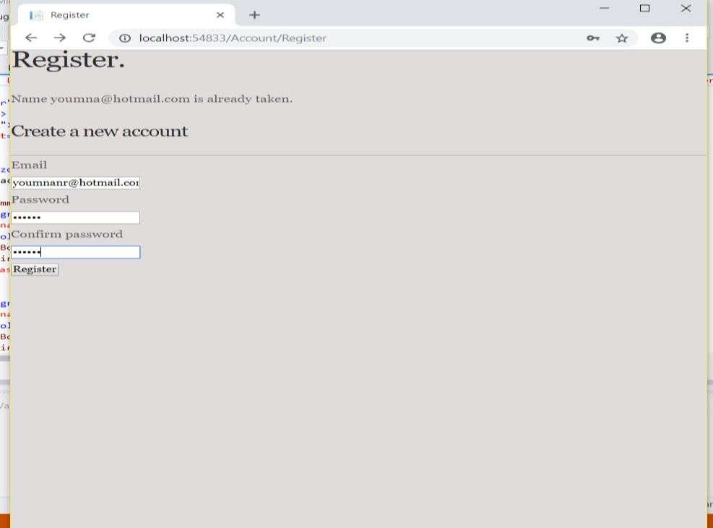

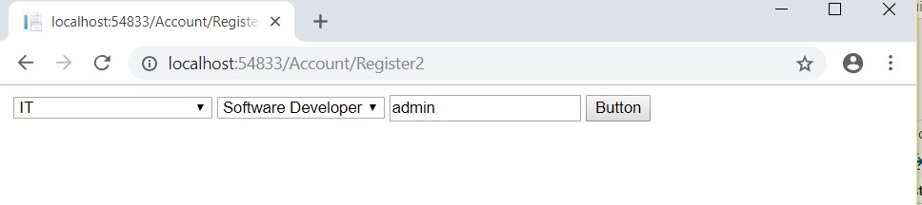

Logging in:

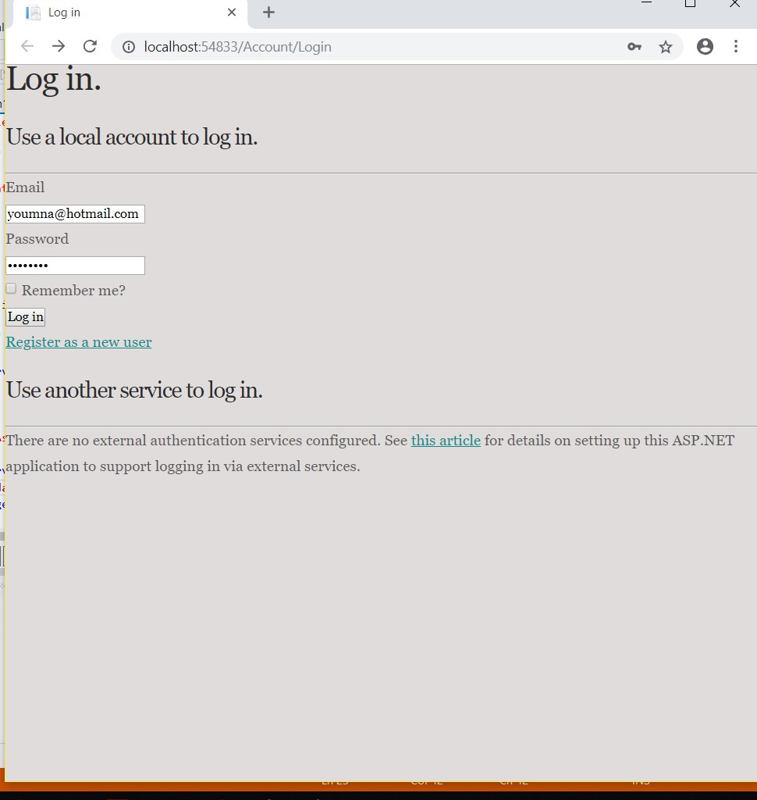

If logged in as a manger:

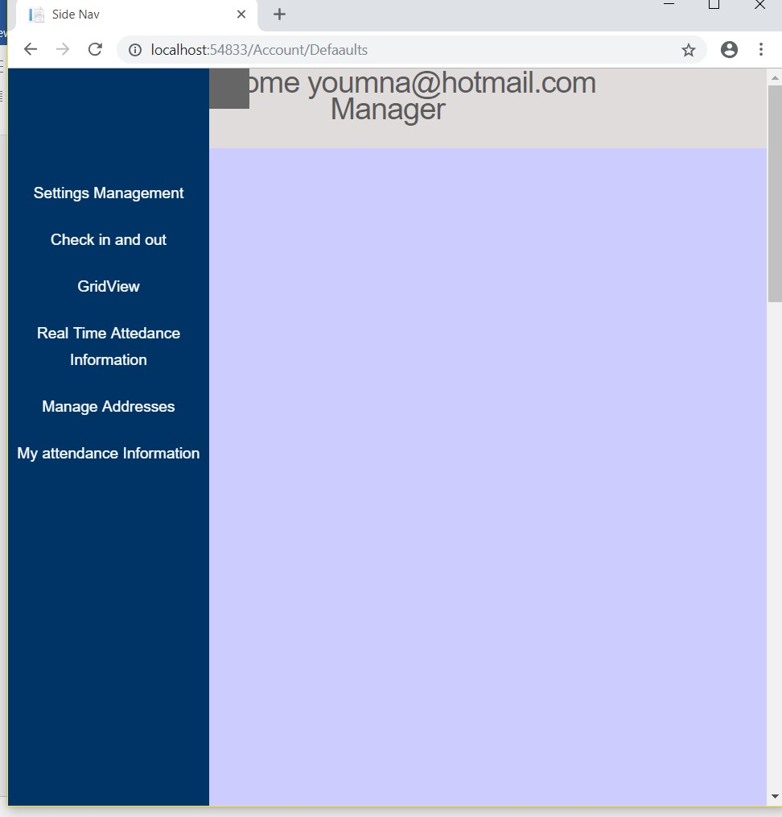

While logging in as an employee shows the following:

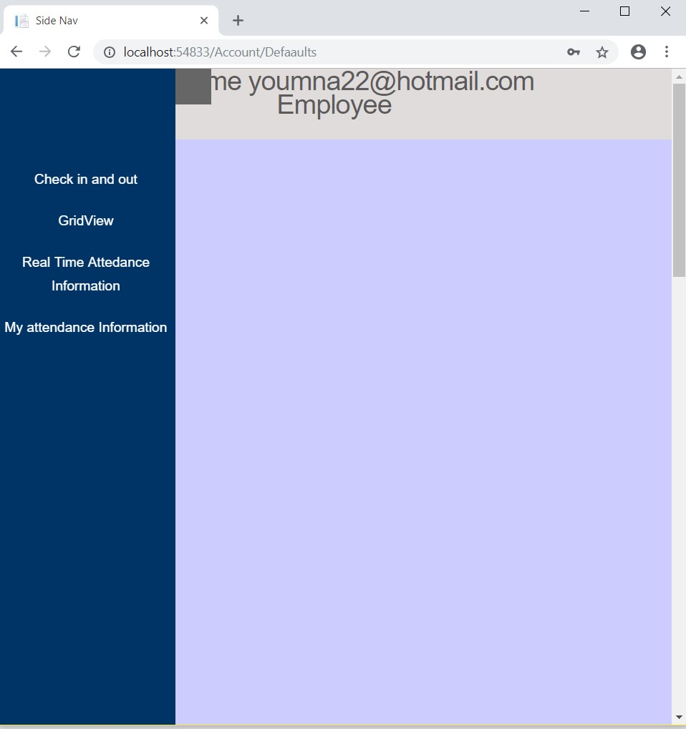

Checking in and out:

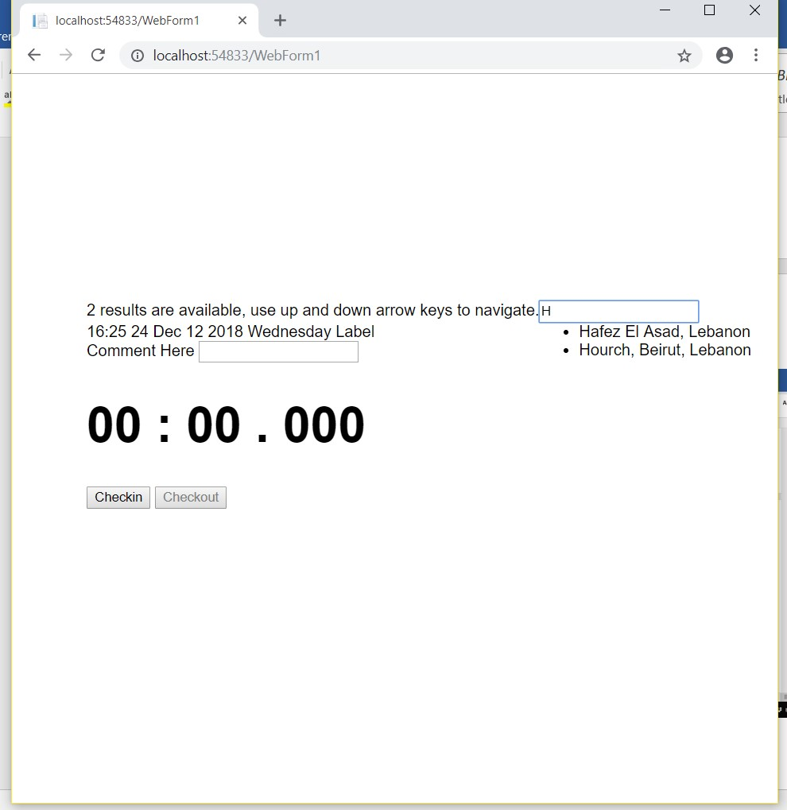

Settings Management:

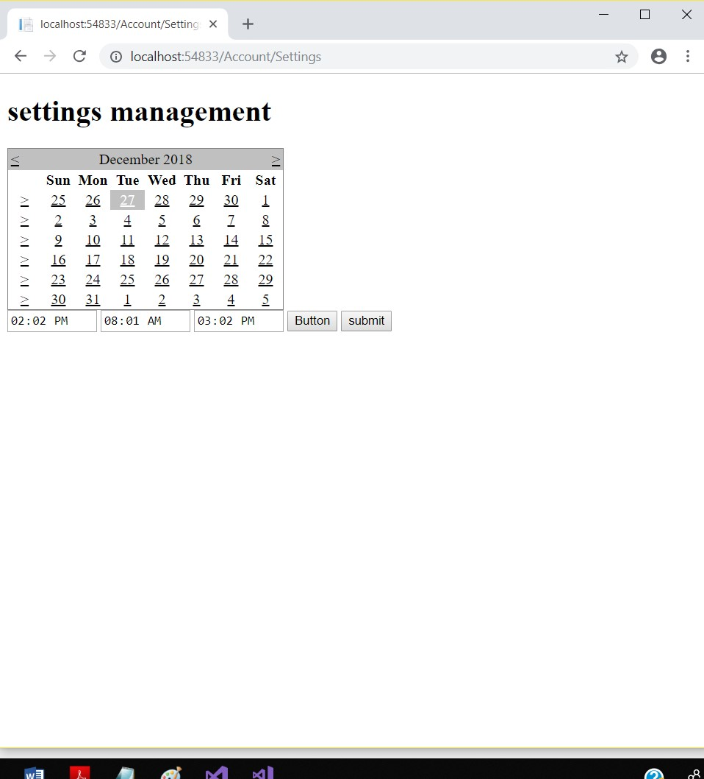

Manage Addresses:

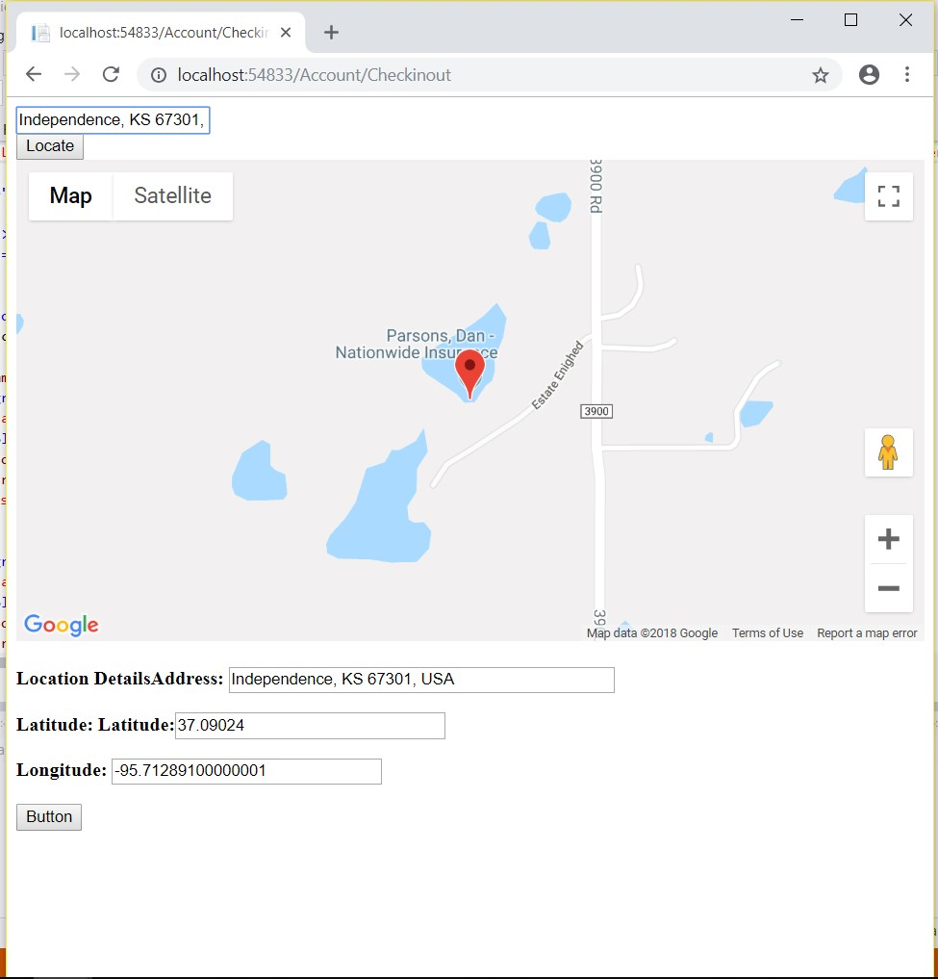

Showing personal information:

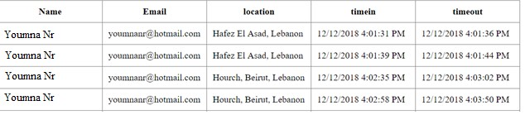

List of Employees:

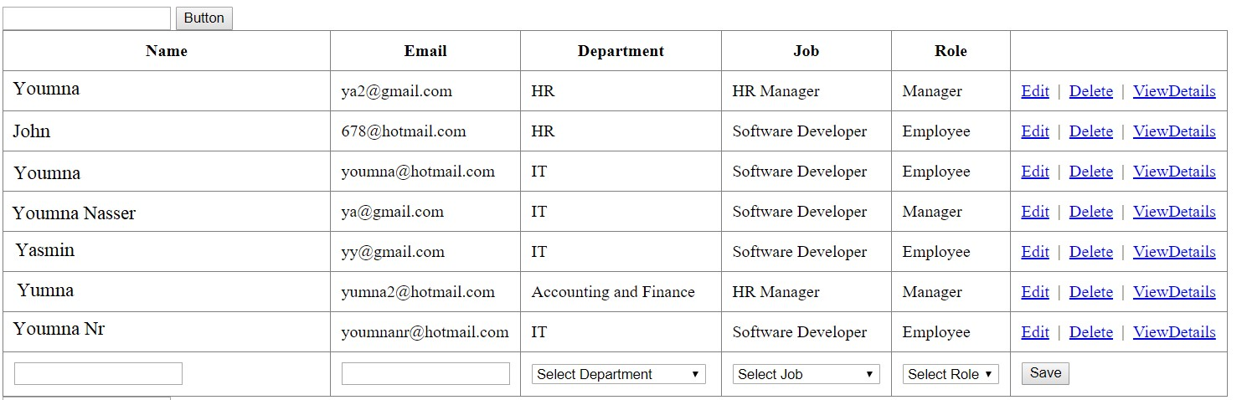

Showing the user’s today check in and out:



# The Soft Skills

### (i)Communication Skills:

One of the keys in building a good project is being able to well communicate and discuss the problems and the structure of the project with the team. Communication skills are essential in order to come out with the best outcome possible, where being able to explore all the aspects of a project with the team and being able to express our ideas clearly to the other person promotes better results.

### (ii)Self-Learning:

Since my internship was an online one, this was another reason to rely on myself in order to learn how to implement the assignments. Being able to teach oneself new things is important in the computer science field, as one must evolve with the rising trends technologies and learn these new techniques.

# University Courses Used in the Internship

## CSC 375 Databases Management Systems:

Everything that was taught in this course was fully enough to be able to build a functional database with relational models. The information provided by this course was very important as it’s important to have a solid database to build information upon. In the project we used SQL language and used Microsoft SQL Server to implement the database.

## CSC 490 Software Engineering:

This course provided deep understanding of the structure of any software, including a website. In the software engineering course, we were taught that the main server performs the actual functionalities and sends them to the user. Here the situation was the same, as the back end corresponded to the server and the front end or user interface corresponds to the user. Also, at the end of the project, a report of the design and how the project was implemented needed to be submitted, that is when the techniques of writing a software engineering report that was gained in class were used.

## CSC443 Web Development:

# Future Expectations

This internship helped me realize the different jobs available in just one aspect of computer science that is web development. It gave me a more specific expectation about my future job and the different working aspects it includes.

# Conclusion

This internship has been a fruitful experience in which we got in contact with real life action. Since I had no knowledge in web programming, it was helpful in means of getting to know the basic needs of web programming and the different fields found within this domain, as in for example back end developers vs front end developers. This internship taught us that new challenges will be faced everyday while designing any program, but with the ability of self-learning, and by communicating with others and discussing the project well, these obstacles can be faced easily. So, I figured out that the most important key in having a good company is learning how to face the challenges, as more challenges gives the employees more experience and trains them to face any obstacle.

This experience was a fundamental affair for the future work. It boosted my self-confidence and showed me how to be responsible. That is by asking me to do certain assignments for the developer and learning for our sake new advances in the field on technology.

24

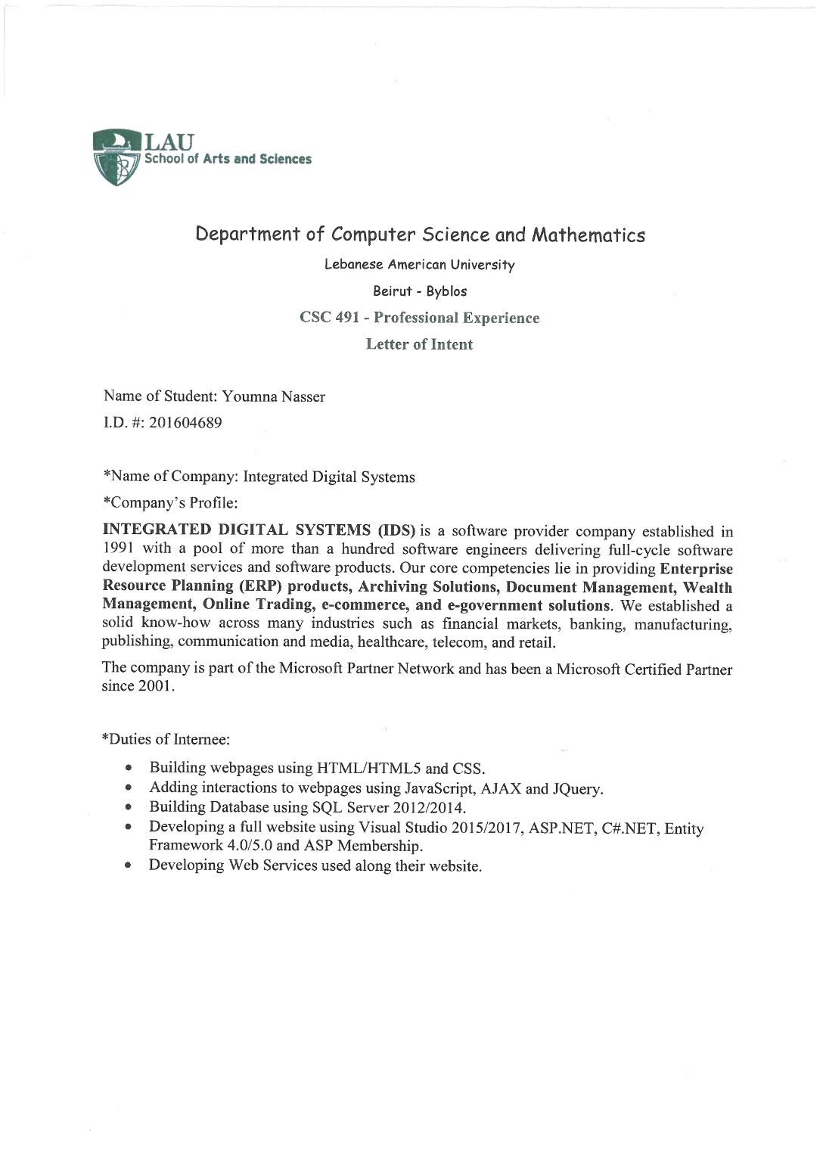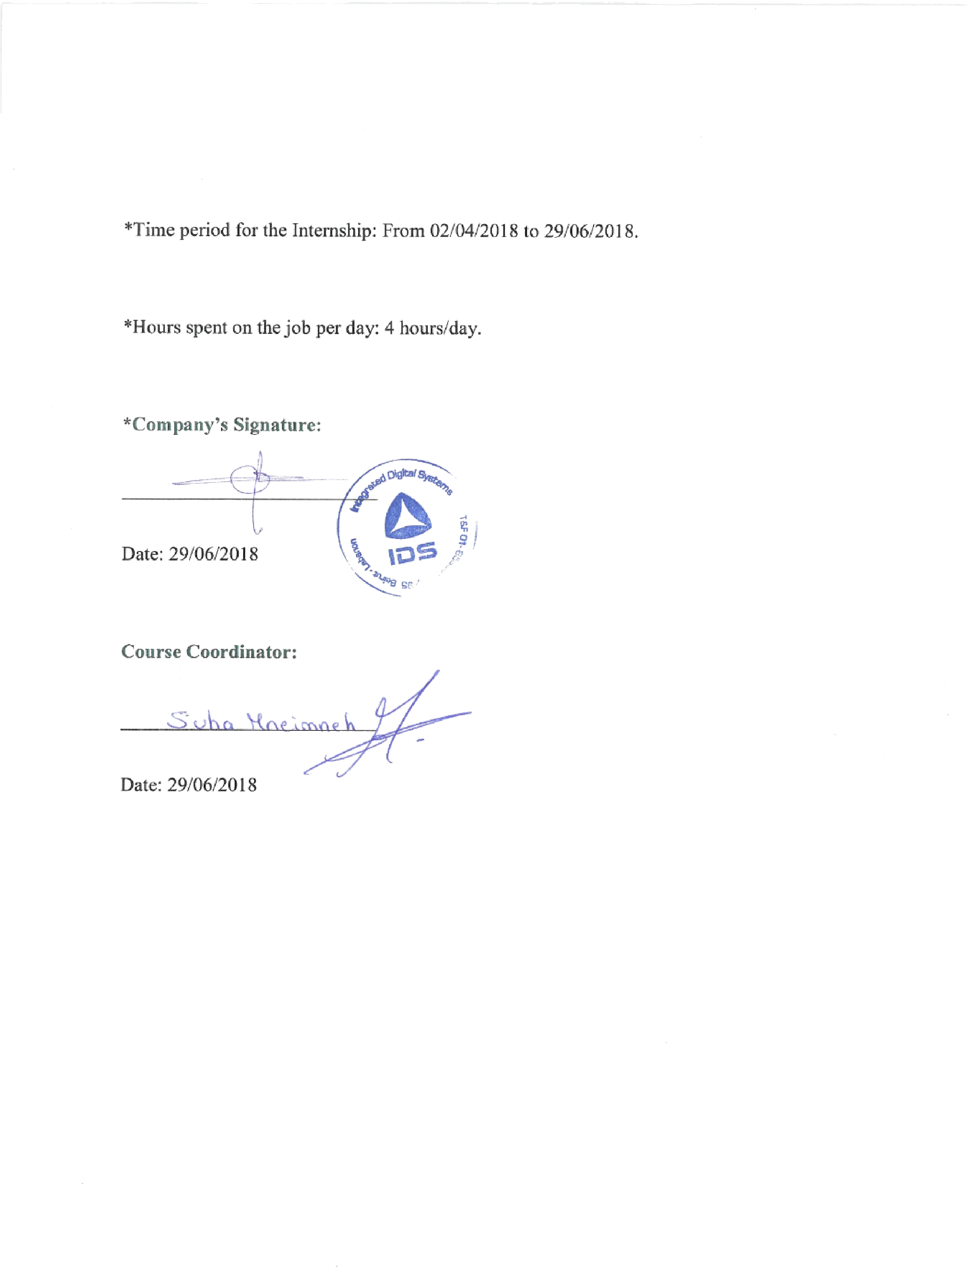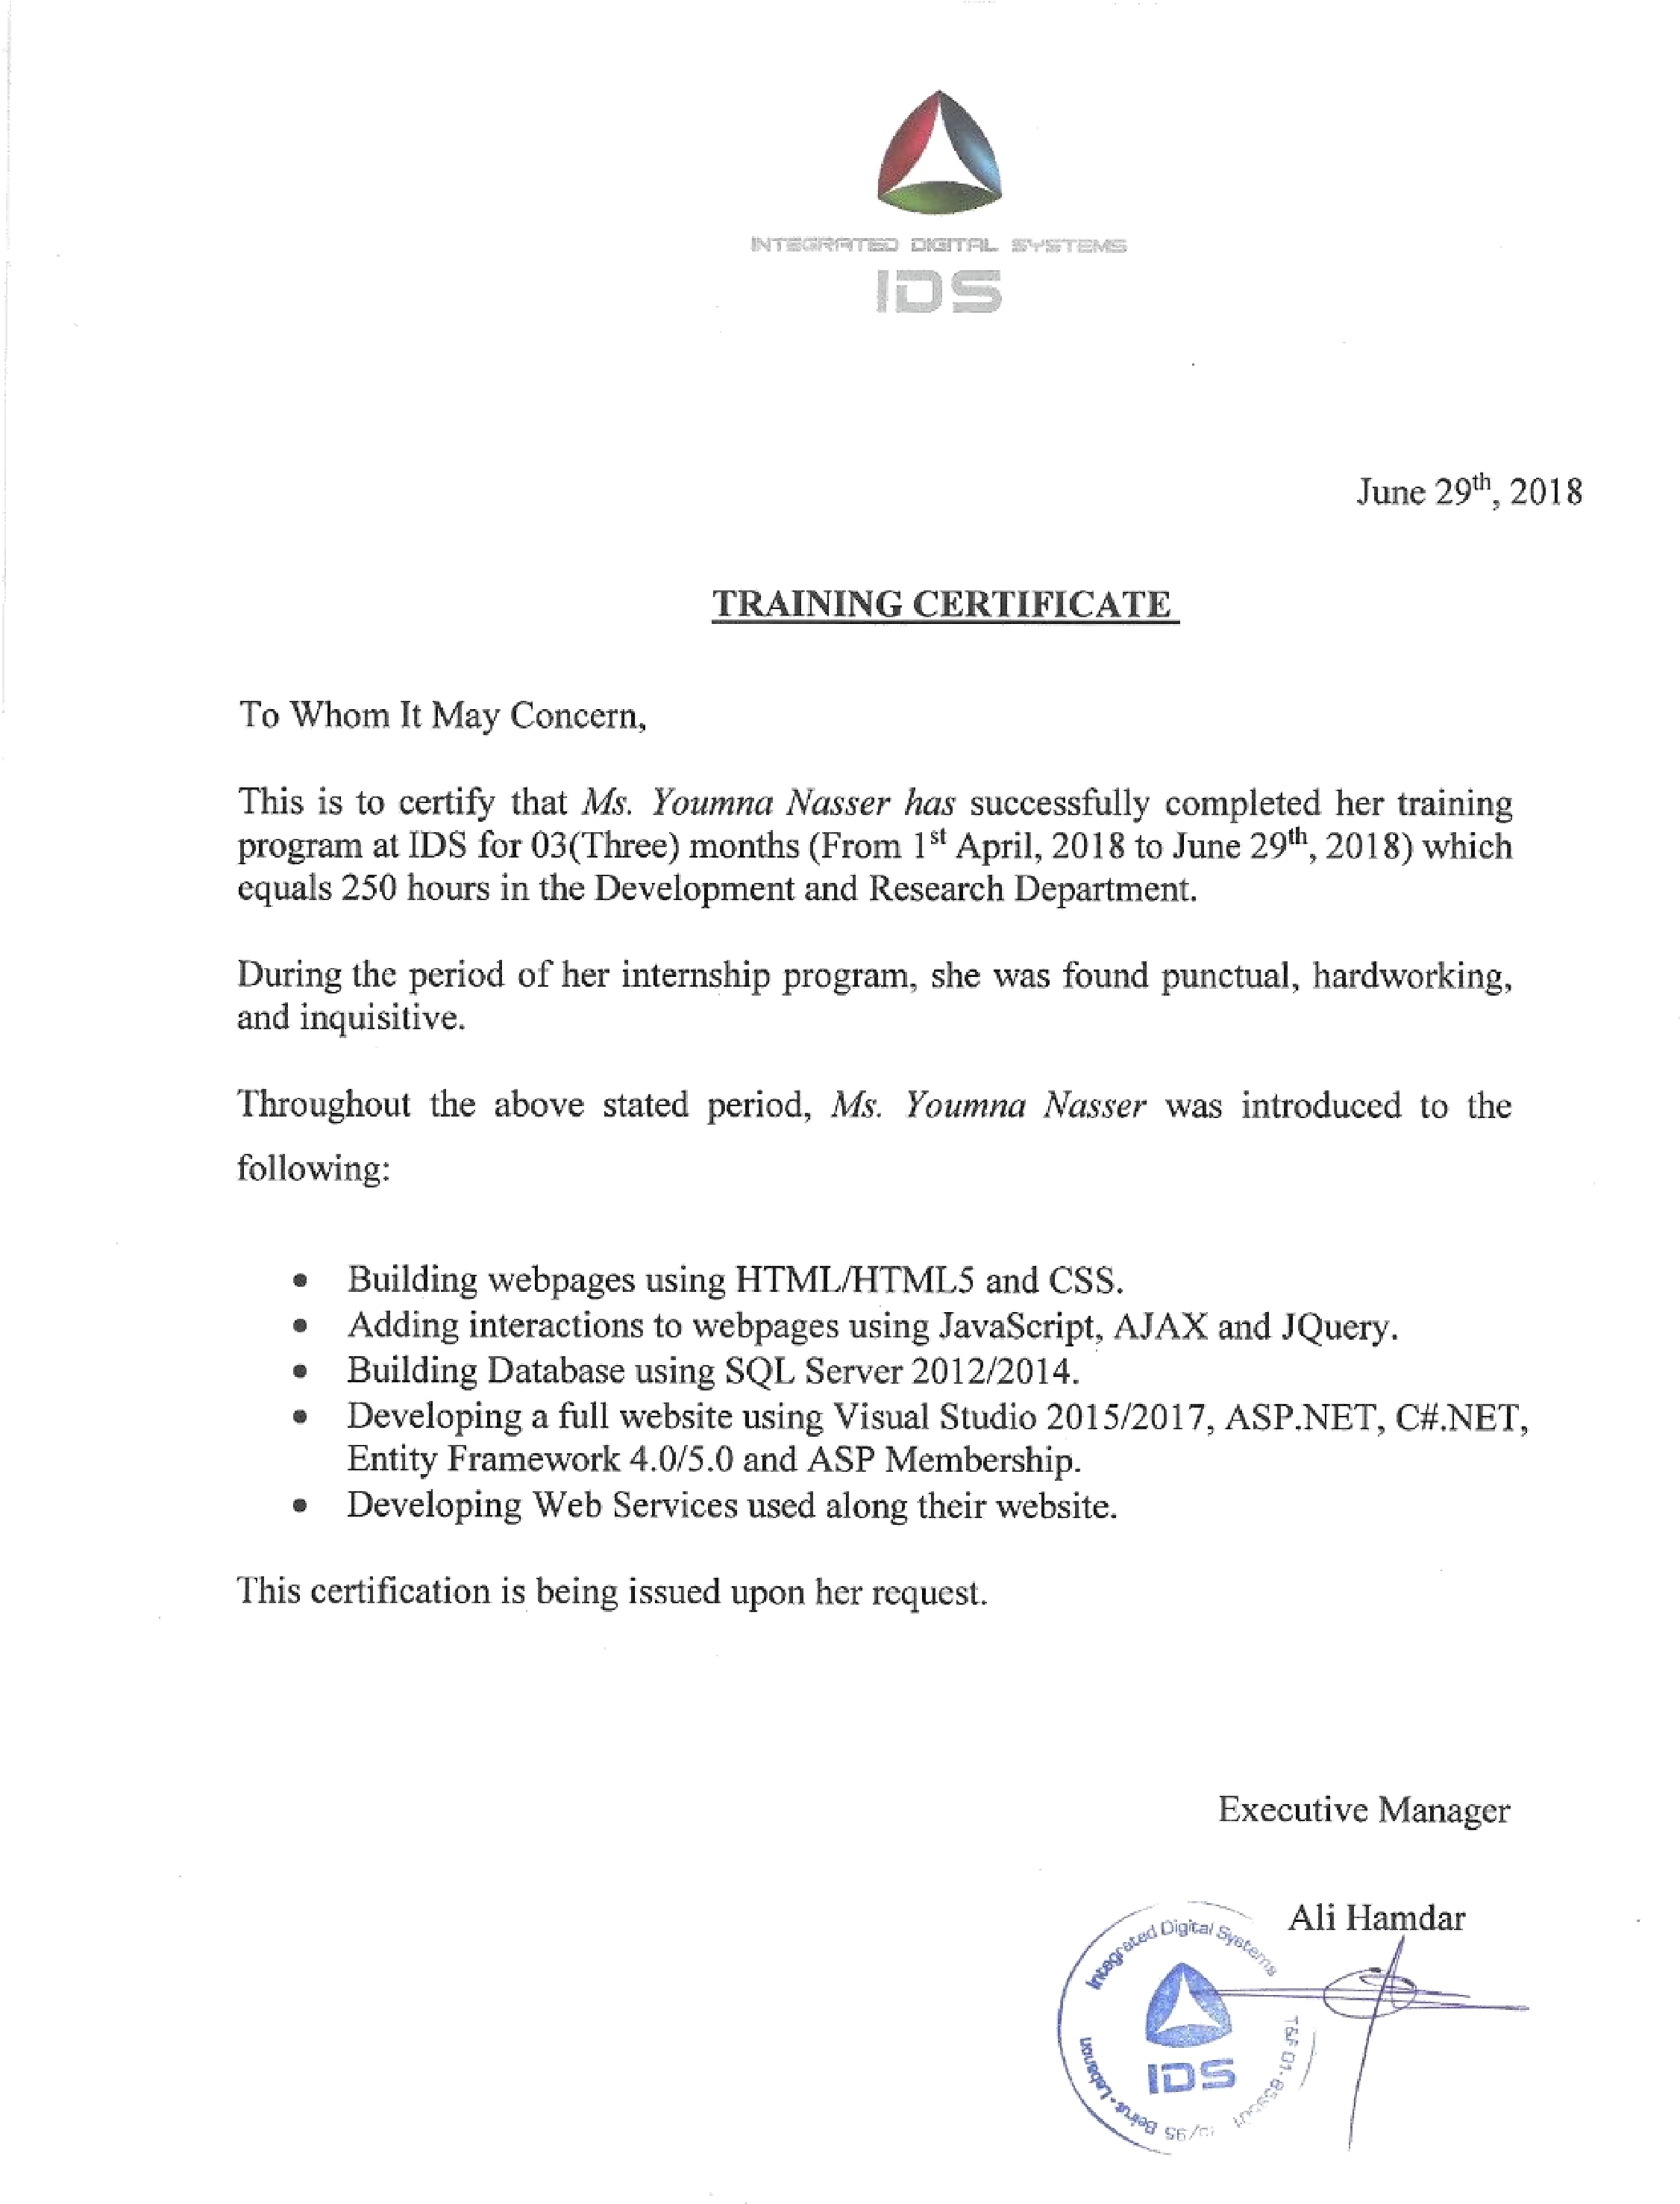

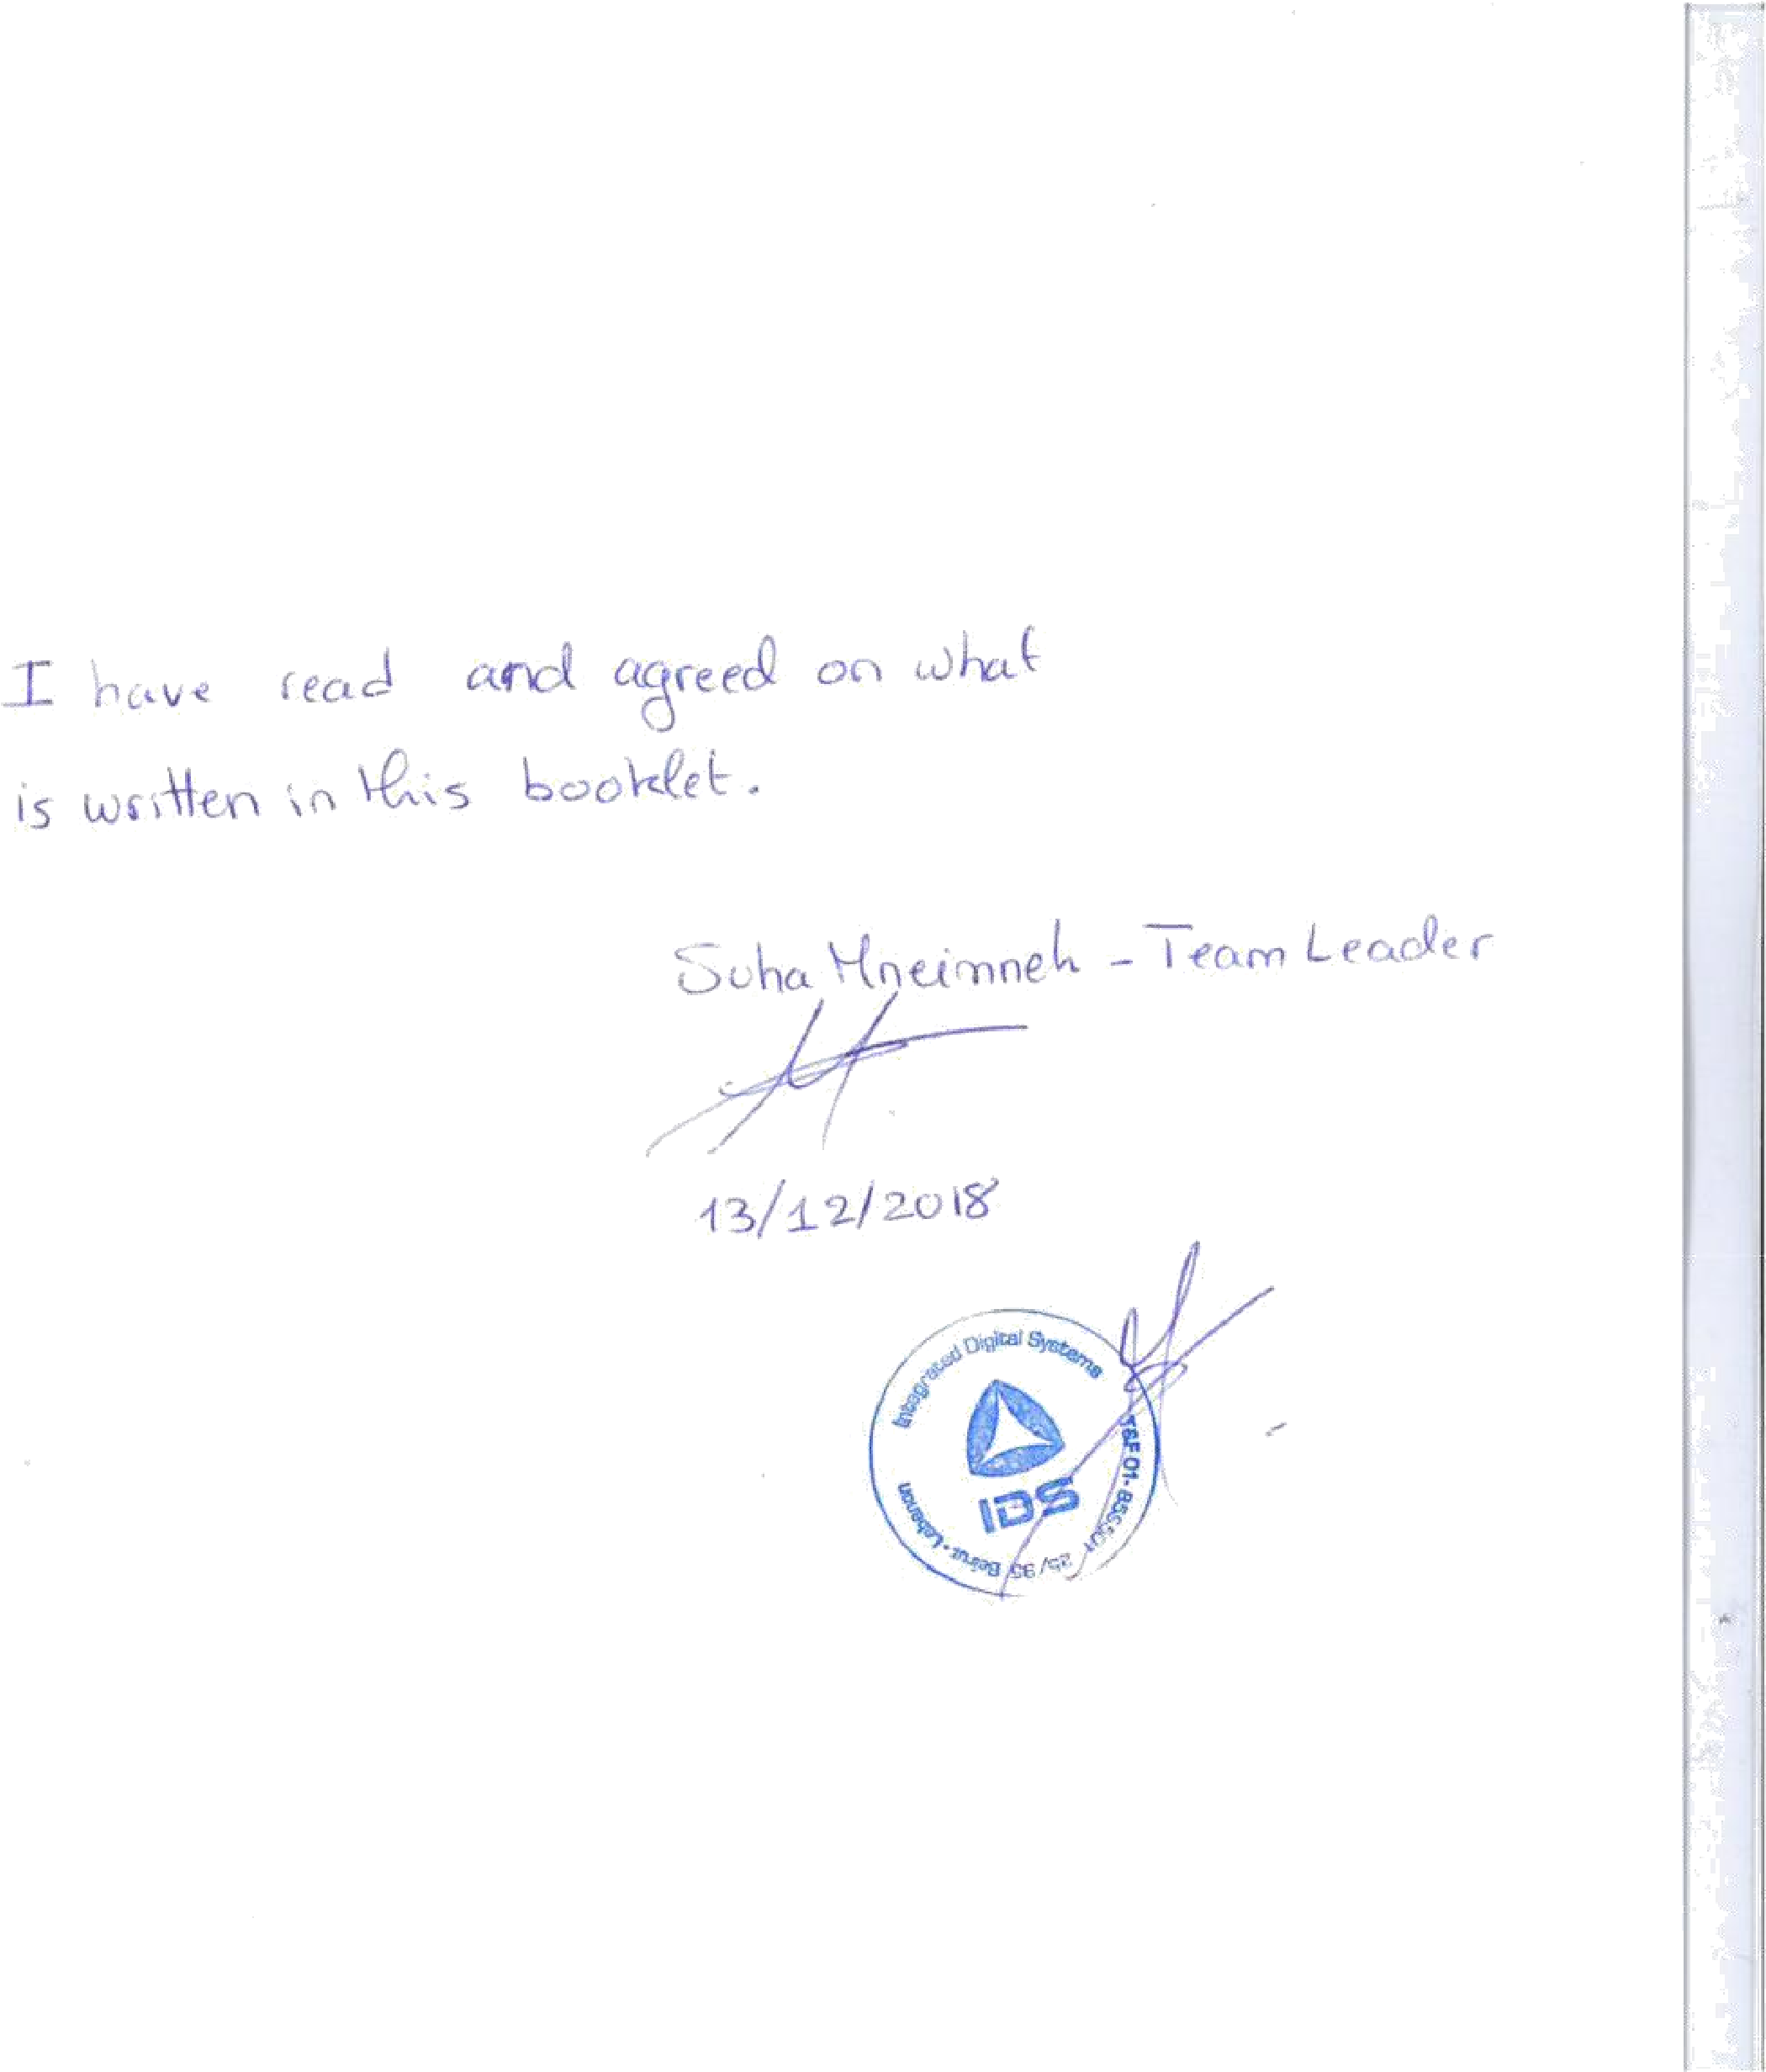

X.References

<http://www.entityframeworktutorial.net/what-is-entityframework.aspx>

[https://docs.microsoft.com/en-us/dotnet/framework/wcf/feature-details/how-to-use-the-aspnetmembership-provider](https://docs.microsoft.com/en-us/dotnet/framework/wcf/feature-details/how-to-use-the-aspnet-membership-provider) <http://www.ids.com.lb/who-we-are>

<https://github.com/NJ015/My_Internship>

<https://github.com/NJ015/MyAreebaInternship>

<https://aneagoie.github.io/robofriends/>

<https://robohash.org/2size=200x200%60>

<https://redux-toolkit.js.org/>

<https://redux-toolkit.js.org/tutorials/quick-start>

<https://www.typescriptlang.org/docs/handbook/typescript-from-scratch.html>

* <https://www.typescriptlang.org/docs/handbook/2/basic-types.html>
* <https://www.typescriptlang.org/docs/handbook/2/functions.html>
* <https://www.typescriptlang.org/docs/handbook/2/everyday-types.html>
* <https://www.typescriptlang.org/docs/handbook/2/objects.html>

<https://formik.org/docs/tutorial>

<https://medium.com/techvblogs/build-crud-api-with-node-js-express-and-mongodb-e3aa58da3915>

<https://mui.com/material-ui/getting-started/installation/>

<https://mui.com/material-ui/getting-started/learn/>

<https://medium.com/techvblogs/build-crud-api-with-node-js-express-and-mongodb-e3aa58da3915>

<https://formik.org/docs/tutorial>

<https://legacy.reactjs.org/docs/conditional-rendering.html#:~:text=Conditional%20rendering%20in%20React%20works,the%20UI%20to%20match%20them.&text=This%20example%20renders%20a%20different,the%20value%20of%20isLoggedIn%20prop>.

<https://jsonplaceholder.typicode.com/>

<https://react.dev/reference/react/hooks>

<https://redux.js.org/tutorials/fundamentals/part-1-overview>

<https://redux.js.org/tutorials/essentials/part-1-overview-concepts>

<https://react.dev/learn/managing-state>

<https://reactrouter.com/en/main/routers/create-browser-router#createbrowserrouter>

<https://www.freecodecamp.org/news/reactive-programming-beginner-guide/>

<https://legacy.reactjs.org/docs/create-a-new-react-app.html>

<https://nodejs.org/en>

<https://react.dev/learn/add-react-to-an-existing-project>

<https://react.dev/learn/installation>

<https://www.w3schools.com/js/js_string_search.asp>

<https://www.w3schools.com/js/js_string_methods.asp>

<https://www.w3schools.com/js/js_strings.asp>

<https://www.w3schools.com/js/js_arrays.asp>

<https://www.w3schools.com/js/js_array_methods.asp>

<https://www.w3schools.com/js/js_array_search.asp>

<https://www.w3schools.com/js/js_array_sort.asp>

<https://www.w3schools.com/js/js_switch.asp>

<https://www.w3schools.com/js/js_if_else.asp>

<https://www.w3schools.com/js/js_json.asp>

<https://www.w3schools.com/js/js_arrow_function.asp>

<https://www.w3schools.com/js/js_classes.asp>

<https://www.freecodecamp.org/news/top-javascript-concepts-to-know-before-learning-react/>

<https://www.w3schools.com/css/css_rwd_mediaqueries.asp>

<https://www.freecodecamp.org/learn/javascript-algorithms-and-data-structures-v8/>

<https://www.freecodecamp.org/learn/2022/responsive-web-design/#learn-html-by-building-a-cat-photo-app>

<https://flexboxfroggy.com/>

<https://www.figma.com/design/7UMHq4rNMaBHPwLUcxnJ11/Retail-E-Commerce-Website-Design-(Community)?node-id=3-447>